Jared Semke

Eli Ledford

Adrian Dionicio Silva

MIPS Project Documentation

C++ Code: Assembly:

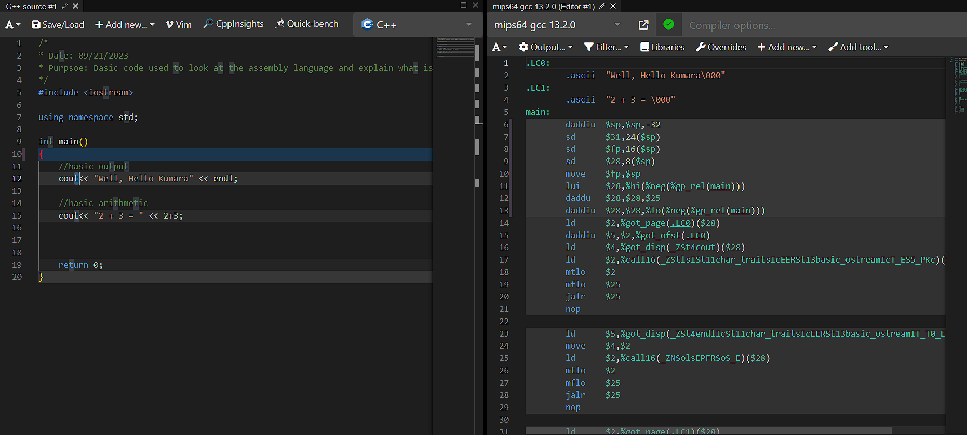

COMPILER EXPLORER WAS USED TO GET THE ASSEMBLY

Prior to runtime execution:

At the beginning of program compilation, the source code is scanned to put the literal and constant values into something called ro-data (read-only data). In this case, the 2 strings placed within the cout function are placed into these memory locations. Once the strings are placed into the ro-data, they cannot be changed. Those values are then converted into ascii values by using the .ascii instruction.

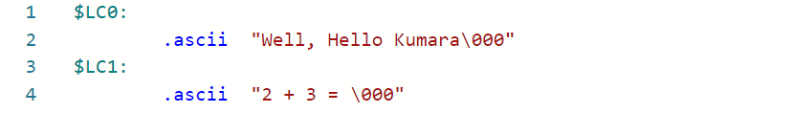

Entering the main method:

When the program begins, the main function is entered. To enter the main function, the memory must be manipulated to create space for the stack and frame pointer. The first instruction that needs to be executed is the subtraction of the stack pointer. This reserves memory space for the function. Then, there are 2 values from the stack pointer that are moved to main memory and into the frame pointer. The value at memory location 28 plus the stack pointer is stored in memory location 31. The value at memory location 24 plus the stack pointer is stored in the frame pointer, which represents the base address of the function.

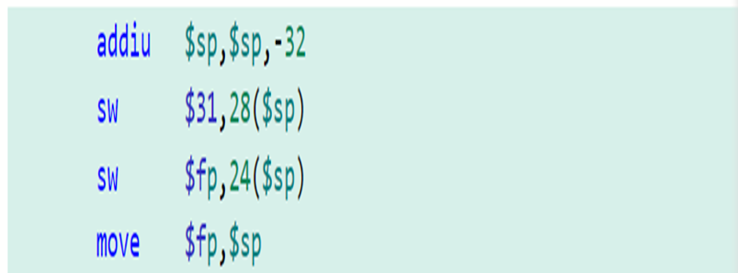

Executing the first line of source code:

The first line of code the executes is a cout statement. The assembly instructions for this line can be broken into 2 parts: the string literal and the newline character (endl). The ro-data values must be accessed and loaded into registers. This is accomplished using lui, which stands for load upper immediate. This takes the upper 16 bits of memory and stores them in $2. The value of $2 is added to the lower 16 bits of ro-data in the next instruction, and stored in $5. The same process of lui and addiu is done again, only this time with the memory locations containing the cout function. The upper 16 bits are stored in $2, and then added with the lower 16 bits in $4. Now that both the data and cout are in memory, we can use the jal function to jump to that function and print the string.

For execution of the newline, the value from $2 must be moved to $3. Remember that $2 still holds the upper 16 bits of the cout function. The lui and addiu must be executed again, only this time with the data for the newline character. The value of $3 has moved to $4, so now the upper 16 of cout are in $4. Now the jal instruction can be used to call the cout function again and execute the newline character.

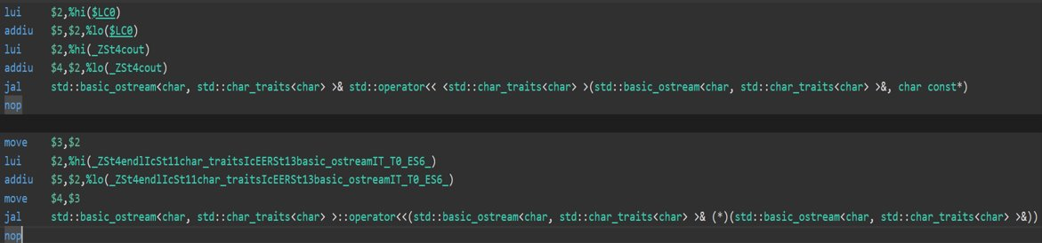

Cout and Basic Arithmetic:

For the second cout statement, the same process for the string literal happens again. The upper 16 bits of the ro-data are loaded, then the lower 16 bits are added with the upper 16 bits and stored in a register. The same process is then done for the cout function. Since we have the data and cout function, we use jal to execute and print the string.

The difference now compared to the previous cout statement is the arithmetic that happens. The li instruction is one that loads the immediate value of 5 into $5. This does the arithmetic of 3 + 2 automatically as the value is encoded in the hardware. The upper 16 bits of the cout function are moved from $2 to $4. We use jal once again to call the cout function and print out 5 to the screen.

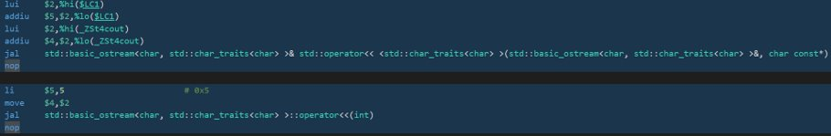

Return 0 and Exiting the Function:

For the return 0 instruction, The value of $0 is moved into $2. Recall that the value of $0 is always 0, so that is what is moved into $2. The closing brace of the function signifies the ending of that function. This has many of the inverse instructions of the opening brace that allowed us to enter the function. First, the frame pointer value is moved into the stack pointer register. Then, that new stack pointer value is then added with 2 different values to load data from memory back into registers. The memory is then deallocated once 32 is added to the stack pointer. The jr instruction jumps the address stored in $31, exiting the function.

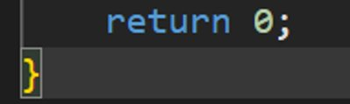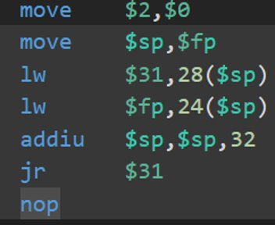

Buffer Vulnerability code

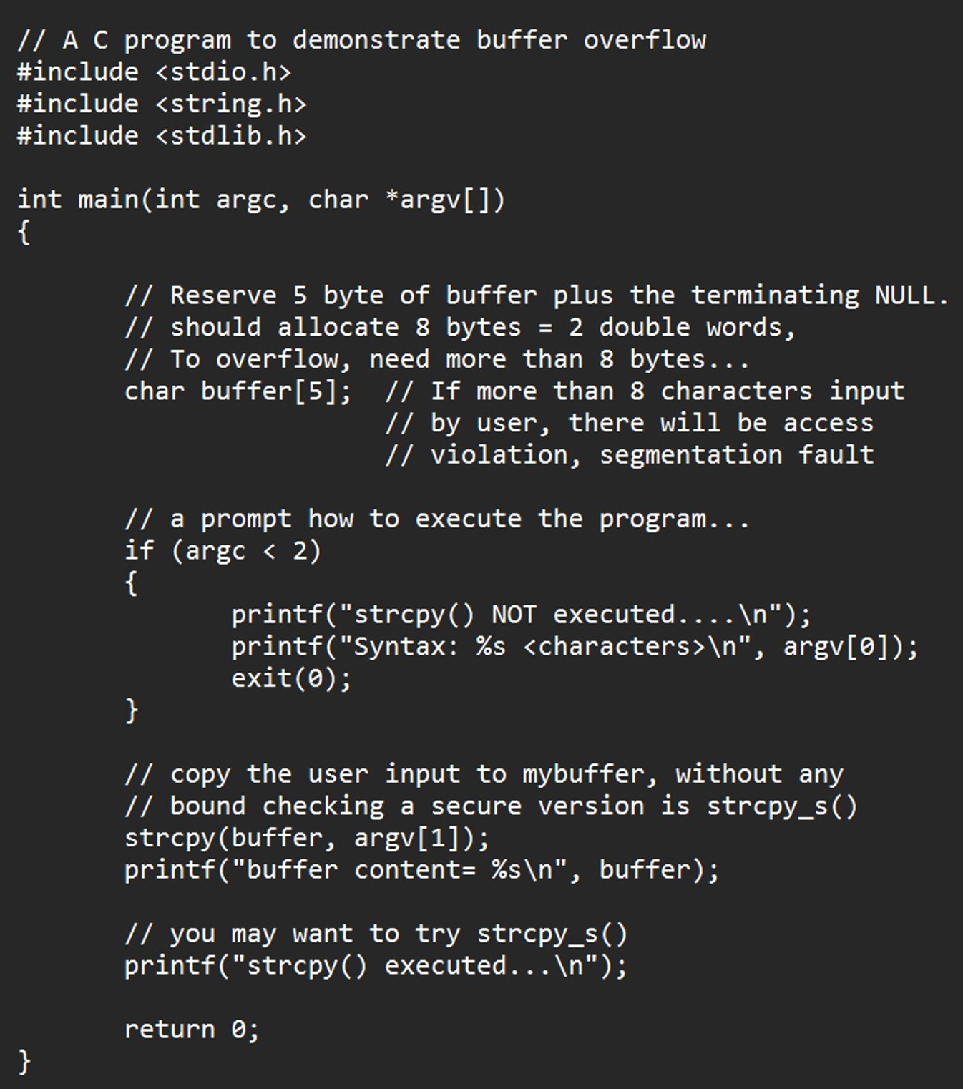

Chat GPT AI explanation of code:

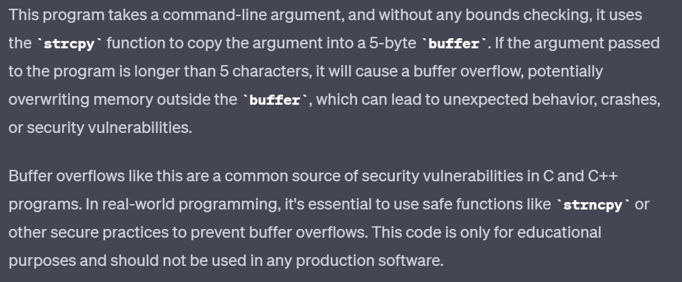Website where we obtained the code’s explination:

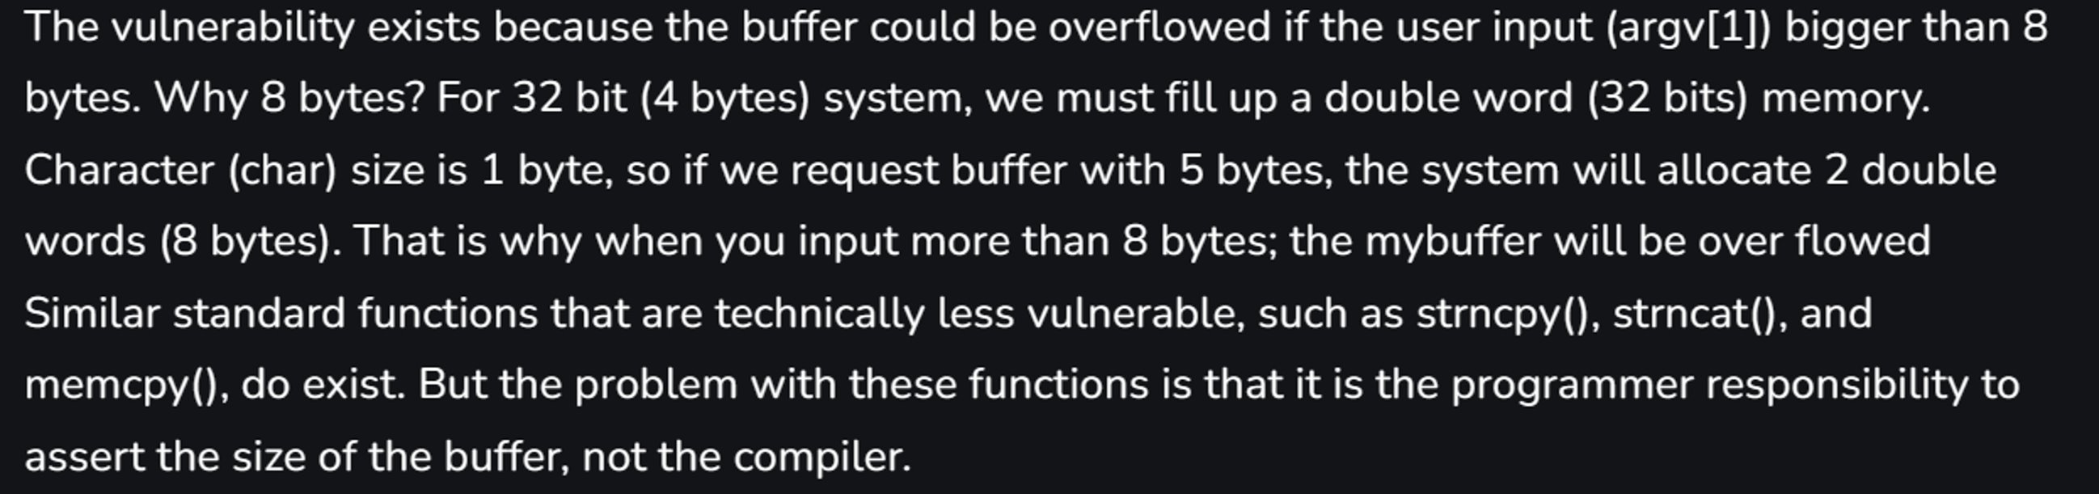

These are the strings stored in the ro-data before program execution.

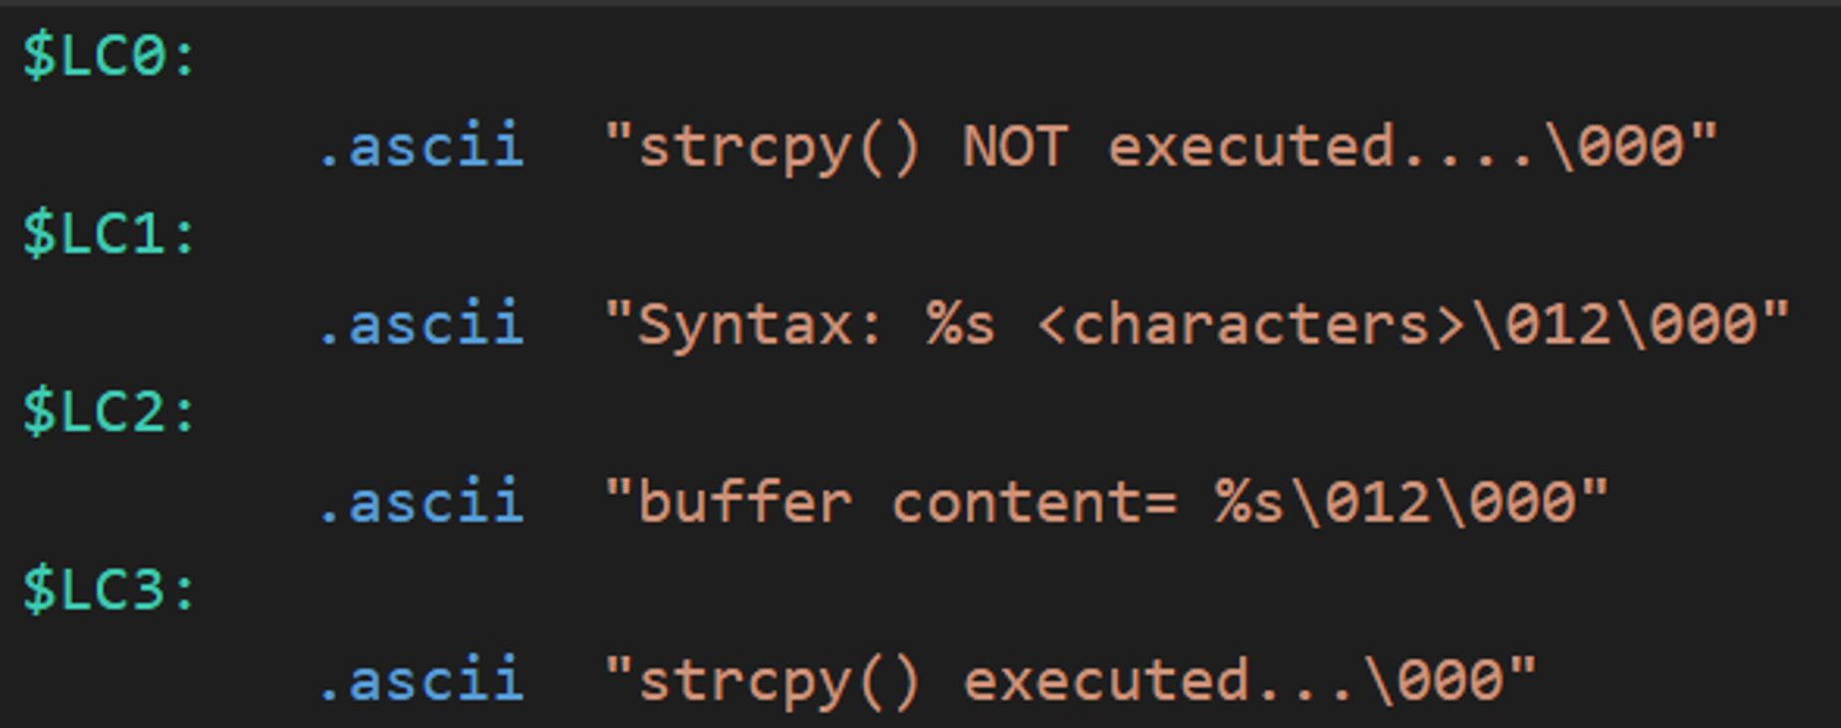

Input problems given by the website and example:

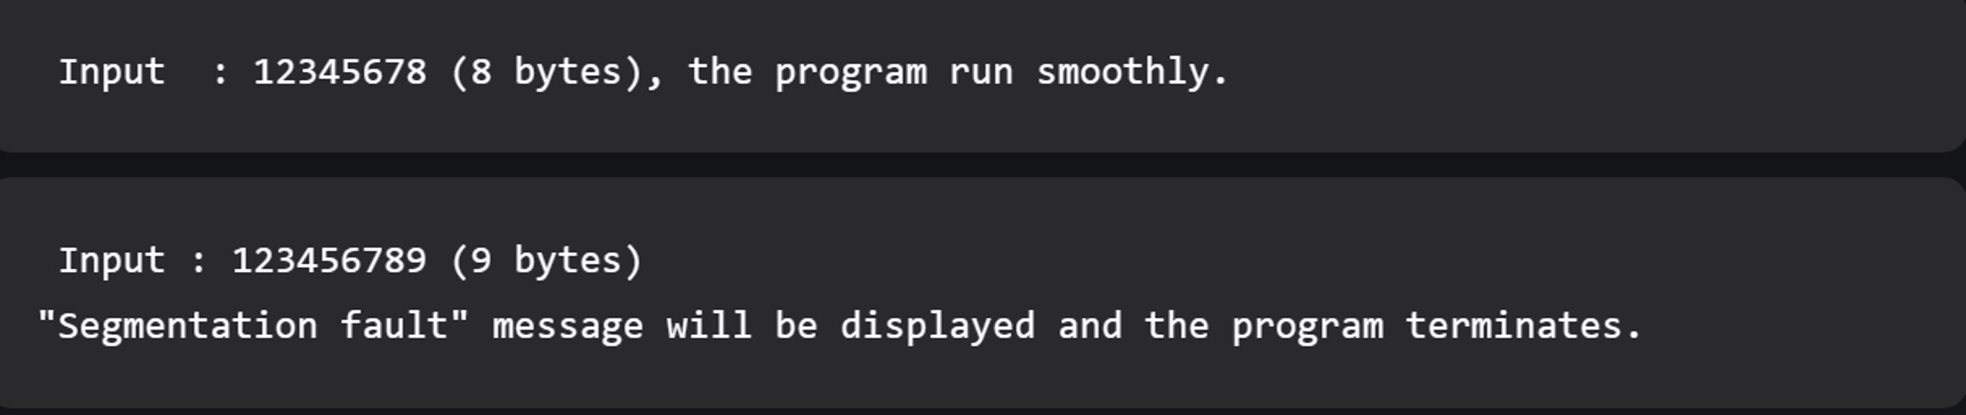

When the main function is entered, some of the values from the registers must be moved to main memory. The stack pointer register value is then moved to the frame pointer register, but not before 40 is subtracted out of the stack pointer to reserve memory.

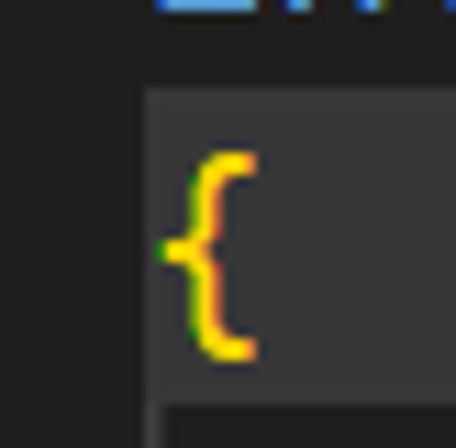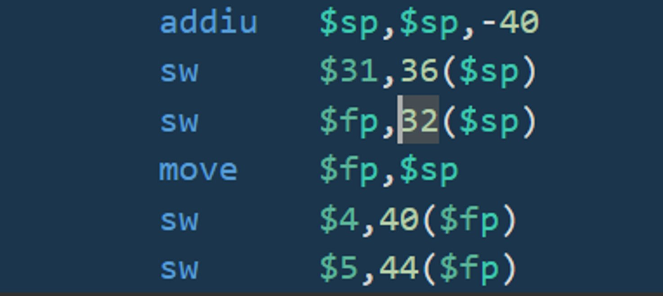

For the if statement, we first load the value at 40 +$fp to $2, which represents argc. Nop is used for a delay, and slt sets $2 to 1 if argc < 2, and set to 0 otherwise. Beq means branch to $L2 if $2 = $0. Remember that the value of $0 is always 0. Because of the slt instruction, the beq instruction is basically asking if argc < 2. The second nop is used for another delay after potential branch.

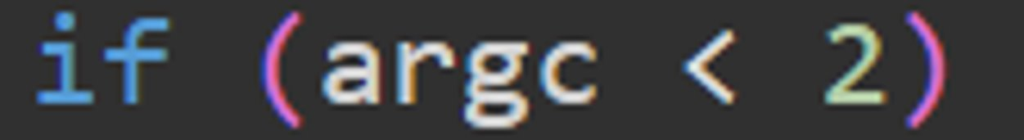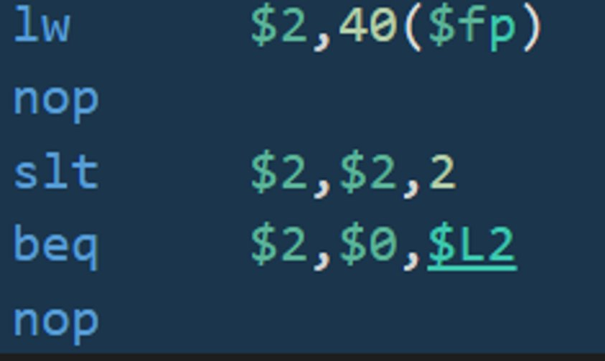

The first 2 instructions involve moving the ro-data so that it can be printed. The lui instruction loads the upper 16 bits of the ro-data into $2. The addiu instruction adds the lower 16 bits with the upper 16 bits stored in $2 and places the result in $4. The jal instruction then calls the puts function, which is the standard output function to the console. The nop instruction is used as a delay operation.

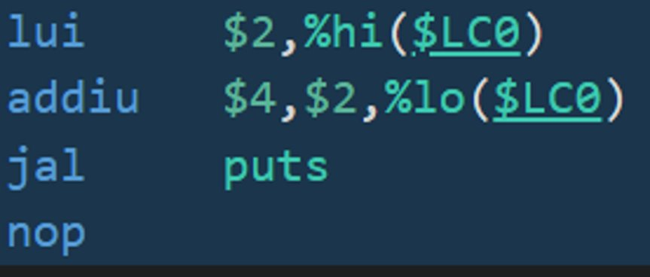

For the first lw instruction, the value at $fp + 44 is loaded into $2. nop is used for delay, and the value at $2 + 0 is loaded into $2. This represents argv[0]. Another nop is used for delay. $2 is then moved into $5. The upper 16 bits of the ro-data are loaded into $2, while the lower 16 bits are then added to the upper 16 and moved to $4. The jal instruction calls printf to print out the string to the console with argv[0] being placed into %s. nop delays the program one more time.

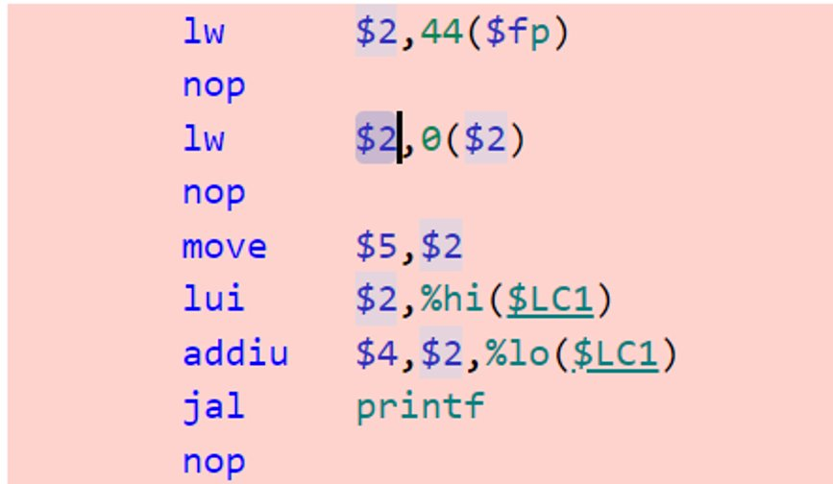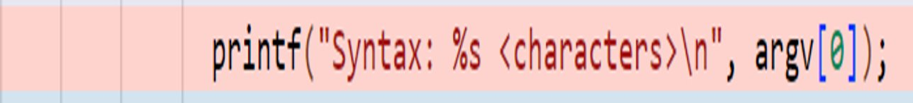

To exit the program, the value of $0 is moved to $4. This means that the value in $4 is 0 since $0 is 0. jal calls the exit function, which exits the program. The nop instruction causes a slight delay.

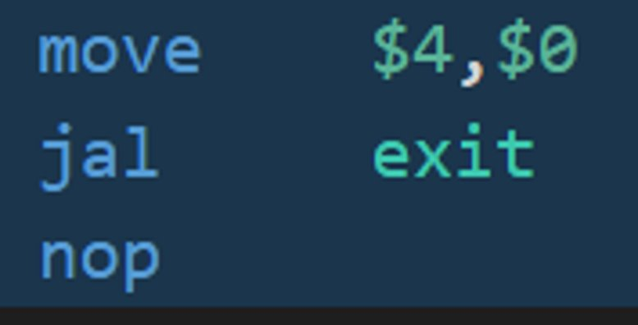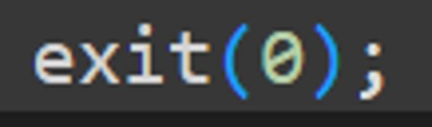

The value at 44 + $fp is loaded into $2. The nop operation is a delay. The value of $2 is added with 4. The value at $2 + 0 is loaded into $2. These instructions correspond with the argv[1] being loaded into the register. Another nop for delay is present. $2 ends up being moved to $5 to free up space. $fp is then added with 24, with the result being stored in $2. That value in $2 is then moved into $4. This is where the buffer resides. The jal instruction calls the strcpy function. The nop causes a final delay.

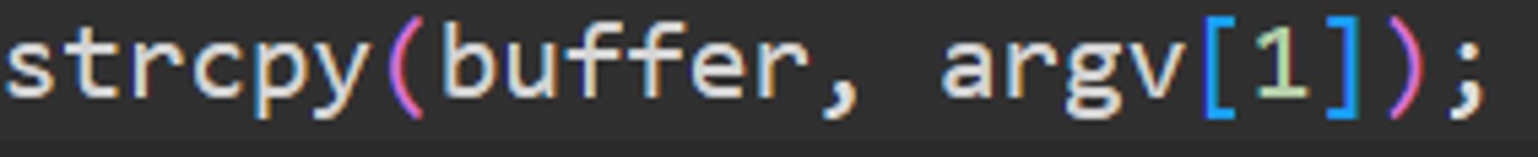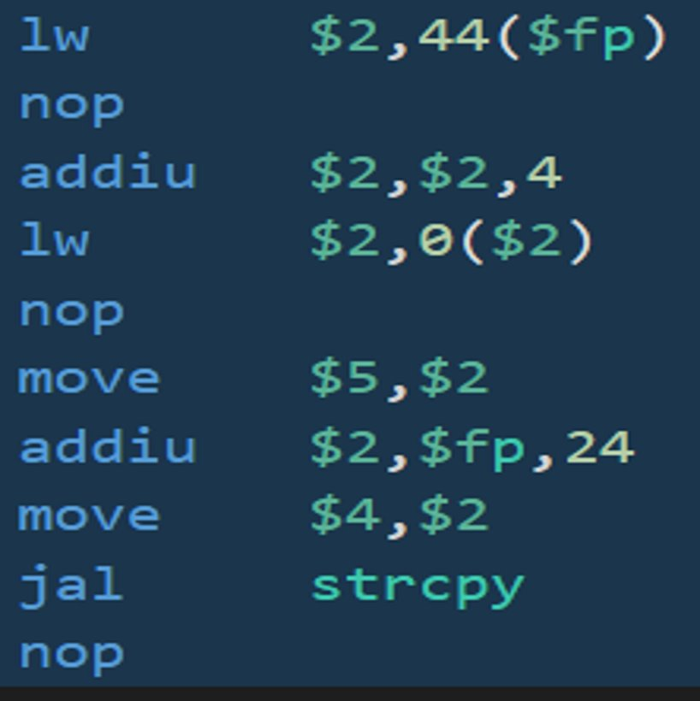

The first 2 instructions load the buffer into a register. $fp is added with 24 and stored in $2, which is then moved into $5. The next 2 instructions moves the upper 16 bits of the ro-data and then adds the lower 16 bits into $4. The printf function is then called using jal, followed by a delay with nop.

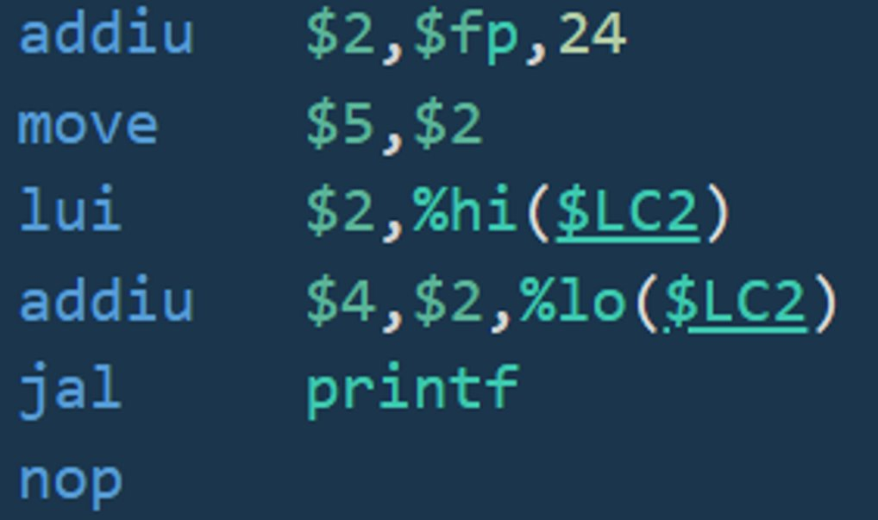

The first 2 instructions load the buffer into a register. $fp is added with 24 and stored in $2, which is then moved into $5. The next 2 instructions moves the upper 16 bits of the ro-data and then adds the lower 16 bits into $4. The printf function is then called using jal, followed by a delay with nop.

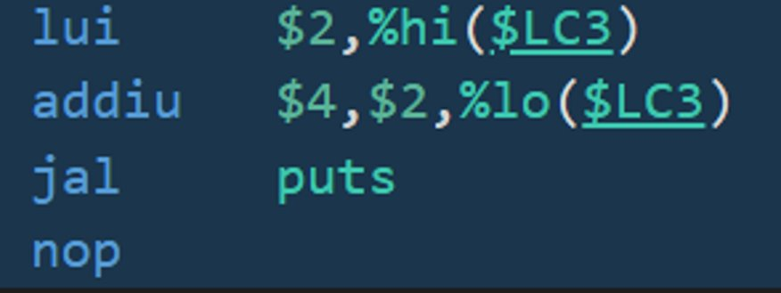

The line with return 0; corresponds with move $2, $0. This moves the value of $0, which is always 0, into $2.

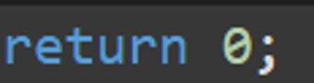

Similar to the opening brace of the function, the closing brace has many of the inverse instructions. The frame pointer value is moved into the stack pointer. The values from memory are being put back into registers, and 40 is added to the stack pointer to deallocate the memory. Jr jumps to the address stored in $31, signaling the end of the function.

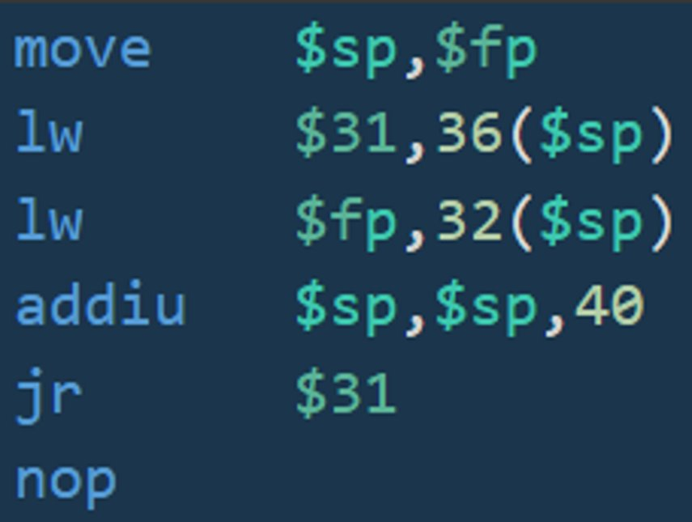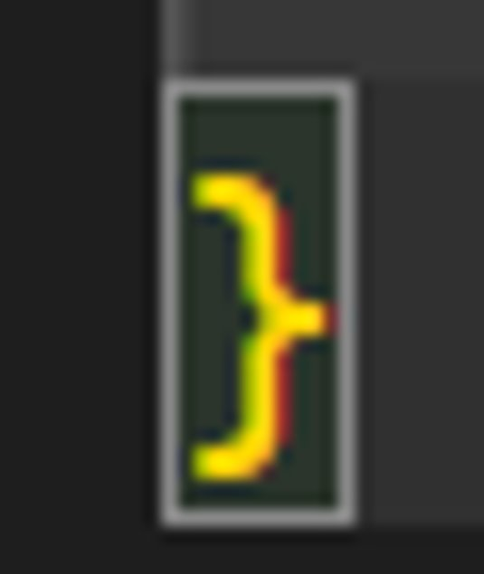

How we got from the buffer overflow source code to binary:

To use Ghidra, you must have a binary file in which you can reverse engineer to assembly and source code. Since we already had the source code, we needed to create the corresponding binary file, which we did using the Microsoft visual studio and the command line:

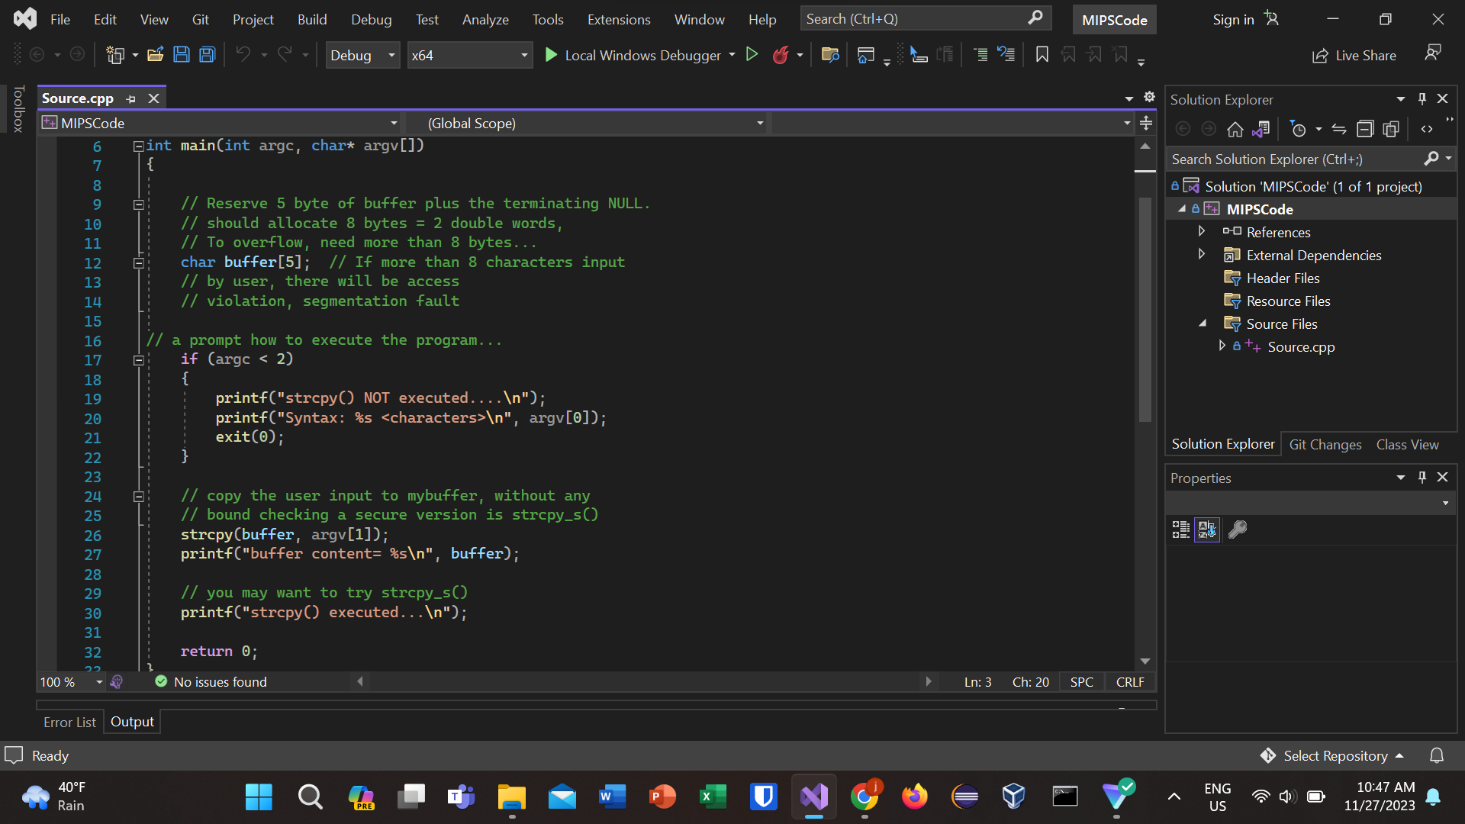

Then we use the command line to compile the code into an executable:



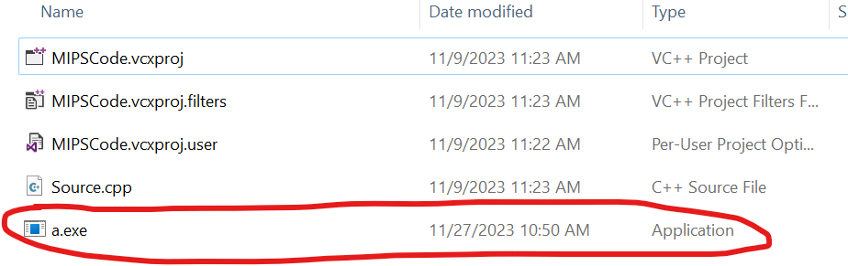

Once we have our executable, we can start Ghidra and import that file into a new project:

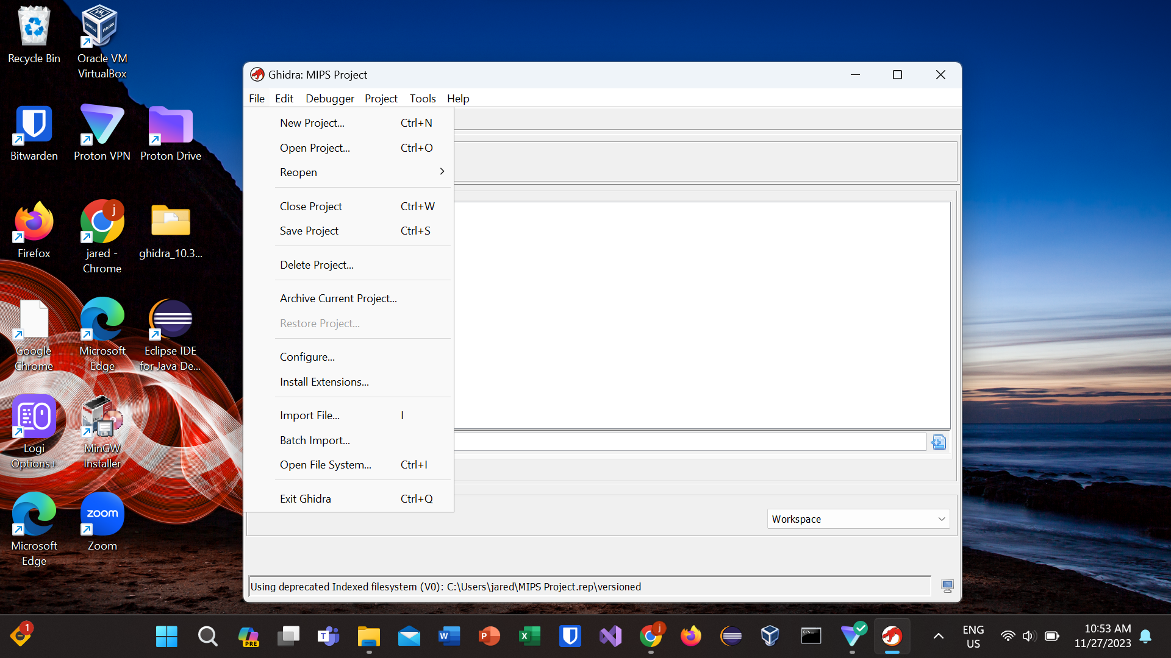

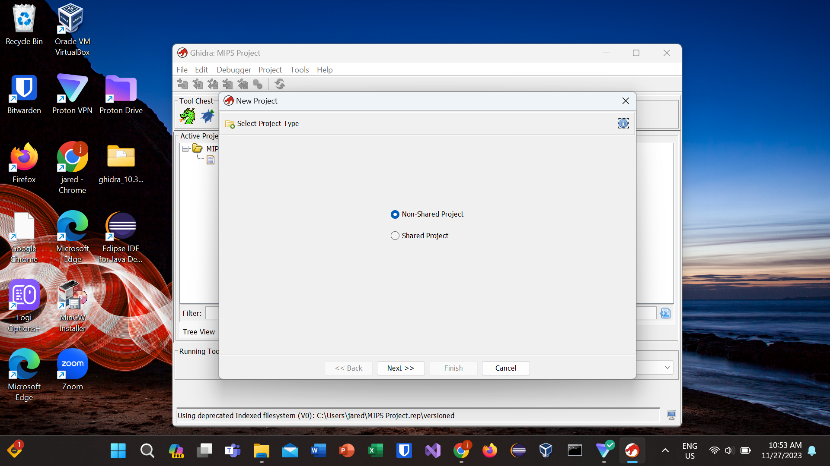

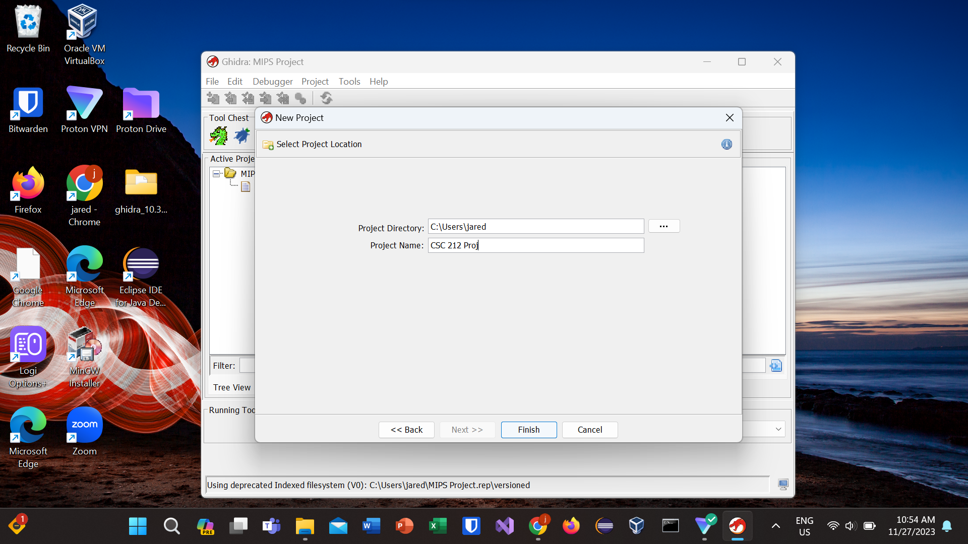

Click on your newly created project and click import file under the file tab:

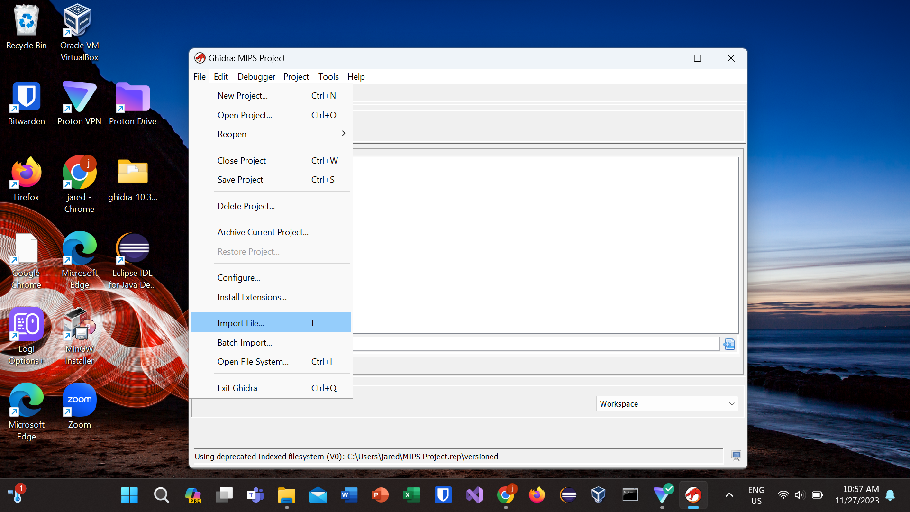

Locate your binary file in your file system and click “select file to import”:

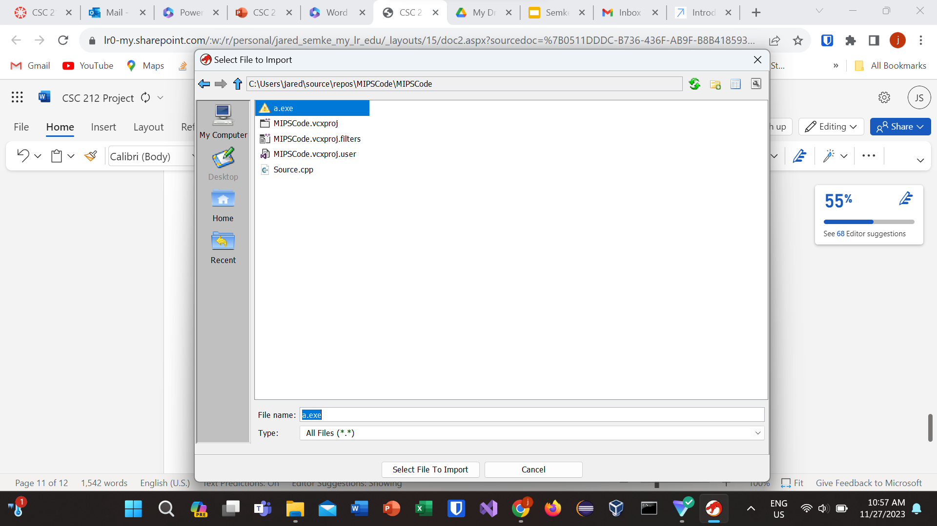

Once your file has been imported, you can use Ghidra’s tools to reverse engineer the file. Click and drag the file to the dragon icon to browse the code. This initially gives you the assembly code:

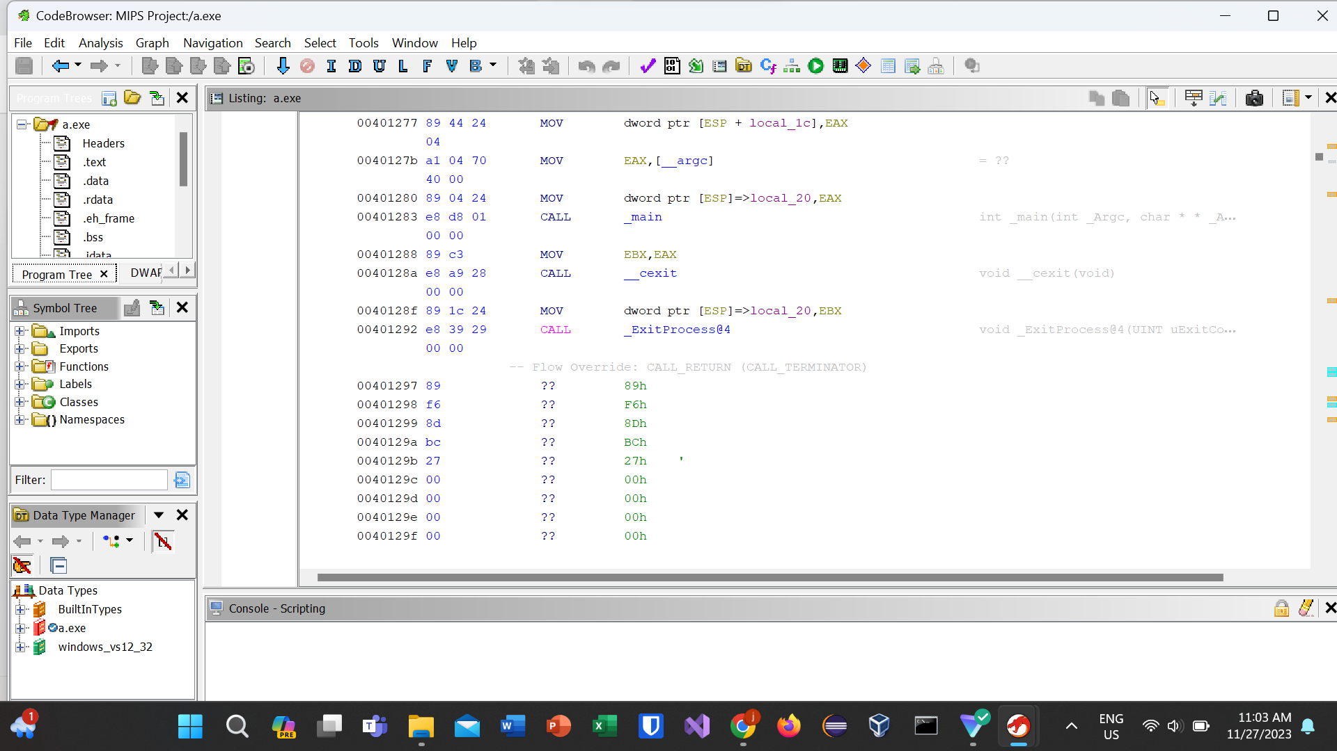

To view the binary for this code, click on the bytes icon on the top bar next to the purple check mark:

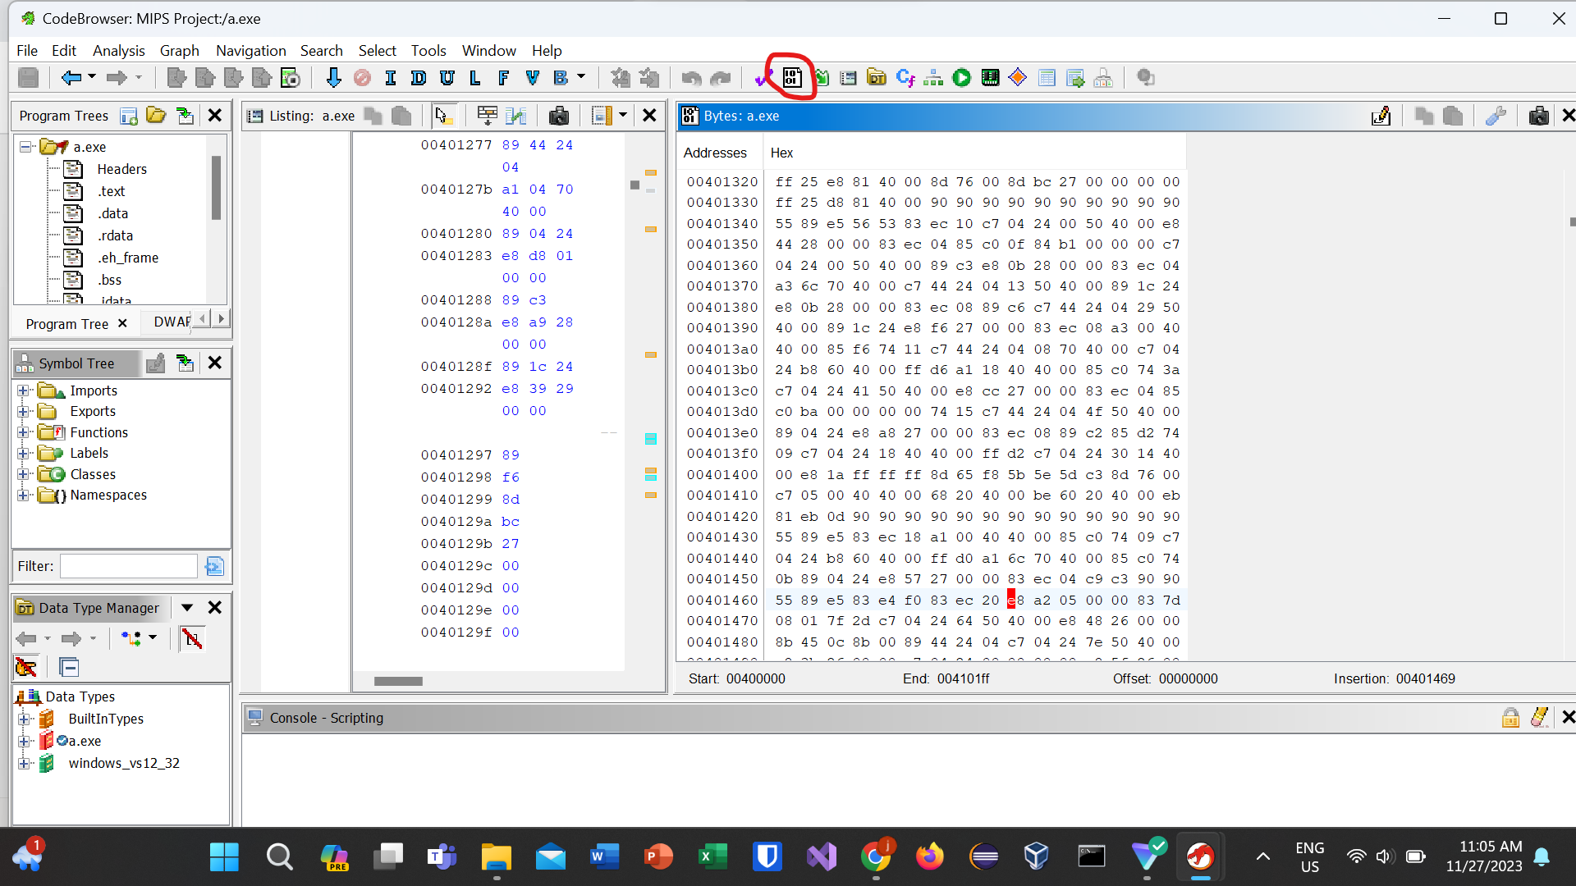

Binary representation of MIPS Assembly Code:

See attached File in Canvas labeled Binary for buff val.txt

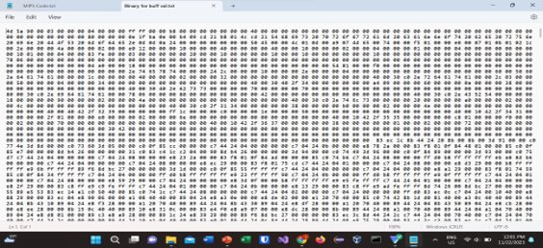

Reverse engineer back to Source Code from Binary in Ghidra:

To turn the binary back into source code, click the decompiler icon with the blue C:

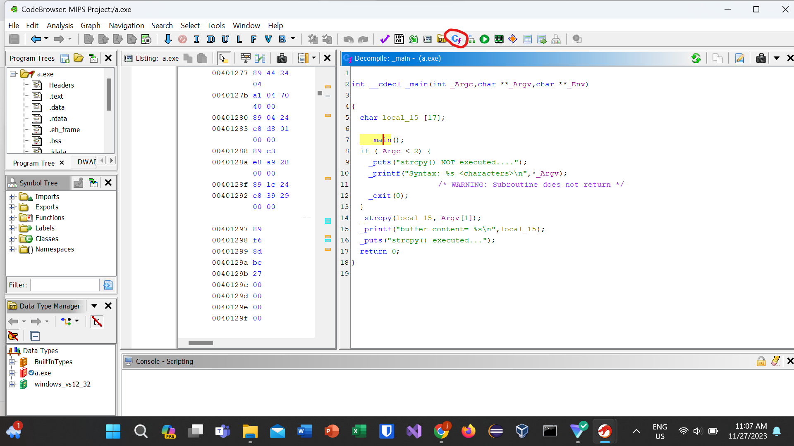

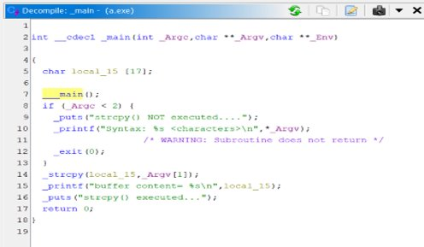

As you can see, it is very closely correlated and almost exactly like the original source code given through the MIPS assembly.

Finding the function call in binary:

To find the call of the main method in the binary from Ghidra, we use the find next function button on the top bar, which takes the cursor to the function call in binary:

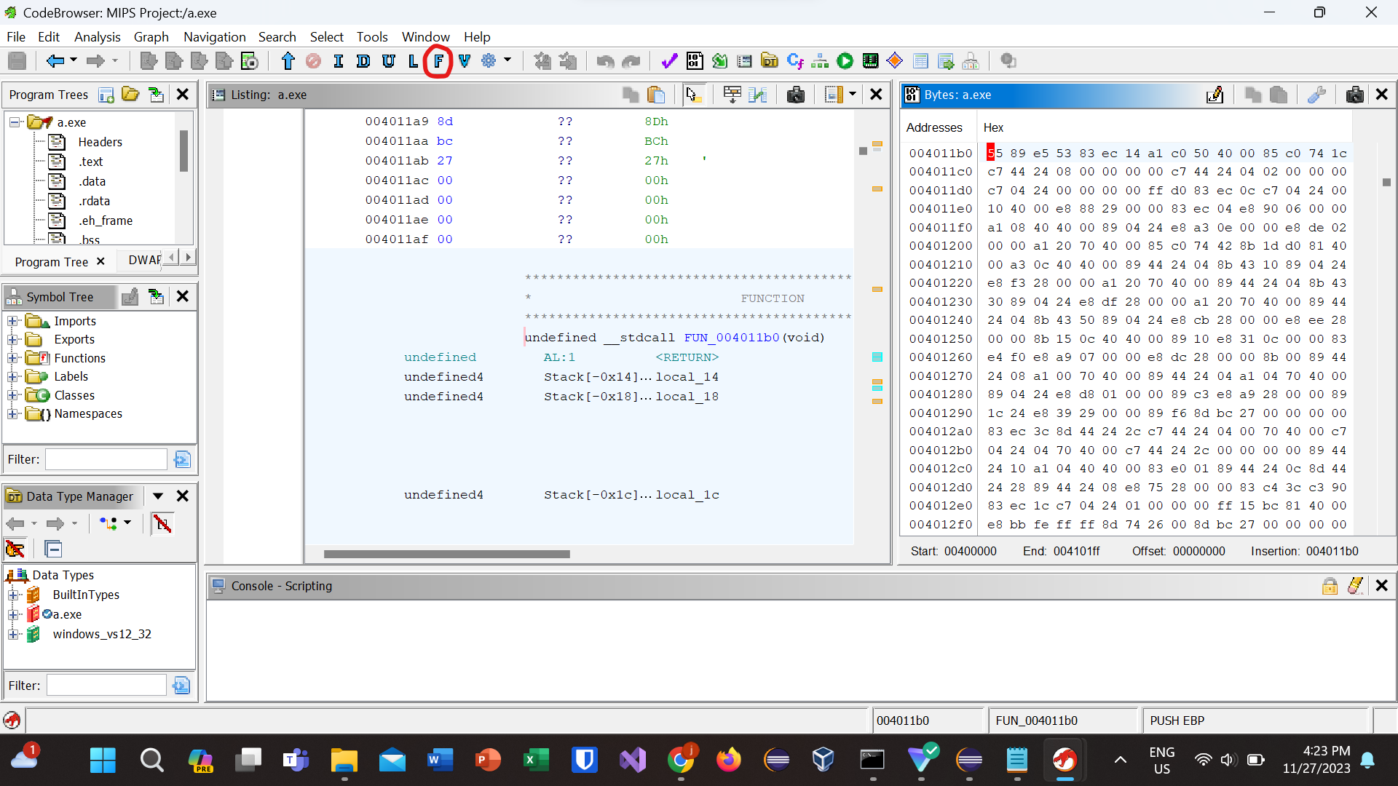

Finding Control Structures:

To find control structures, use decompile, then find the control expression in the source code. Stay on the highlighted assembly line that corresponds to the control structure, then pull up the binary. Click on the assembly instruction again, and that will take you to the instruction in binary:

